**Final Report**

**Project Title:** Marine Invasive Species Technical Support – Quantitative Survey of Nonindigenous Species (NIS) in Prince William Sound: Plankton

**Contract number:** 952.13.01

**Submitted to:** Prince William Sound Regional Citizens’ Advisory Council

**Date:** November 2013

**Principal Investigators:**

Jon Geller, Moss Landing Marine Laboratory, California State University, Moss Landing CA: Phone 831-771-4436; Email: geller@mlml.calstate.edu

Greg Ruiz, Smithsonian Environmental Research Center, P.O. Box 28, Edgewater MD 21037; Phone 443-482-2227; Email: ruizg@si.edu

***The opinions expressed in this PWSRCAC-commissioned report are not necessarily those of PWSRCAC.***

**INTRODUCTION**

Invasions by non-native species are a major force of change in coastal marine ecosystems around the world that is increasing over time. Most non-native species in marine systems are known from temperate latitudes in coastal waters, and especially bays and estuaries, where (a) over 100 non-native species can occur in a single estuary, and (b) the detection rate for new invasions is increasing at an exponential rate (Cohen and Carlton 1998, Ruiz et al. 2000). While relatively few non-native species richness (number) are known at high latitudes, this is also changing as a result of human-aided transport and climate change (Ruiz and Hewitt 2009, Ruiz et al. 2011).

Critical to any attempt to reduce or remediate invasions is the ability to detect and quantify the occurrence of non-native species and especially changes over time (Ruiz and Carlton 2003). Such measures provide vital information about the vectors (transfer mechanisms) involved and the efficacy of management strategies to minimize new incursions. In addition, detection of new incursions may also be used for control or eradication efforts to reduce unwanted ecological, economic, or human-health impacts.

Non-native species may occur in any habitat, including man-made structures (docks, floats, boats), natural hard substrata, on other organisms (as symbionts), in sediments, and the water column as plankton. To date, the most comprehensive assessments of invasions have sought to sample many different habitats with diverse methods. Yet, plankton communities consist of holoplankton and the planktonic larval stages of species (native and non-native) from all habitats, and sampling the plankton may serve as a single, integrative method to detect a large subset of species from all habitats.

Although plankton is relatively easy to obtain, compared to other types of samples, it is among the most difficult to analyze morphologically. The small size of planktonic organisms makes identification challenging, and larval stages of most organisms lack prior description. Genetic analysis of plankton may allow us to overcome this historical limitation, since existing technology can be used to detect species without relying on morphology. Moreover, plankton communities may be particularly amenable to metagenomic approaches, wherein bulk samples of the entire community can be characterized rapidly. Specifically, with metagenomic analysis of plankton, many thousands of individual organisms can be concentrated in a small volume, unlike most benthic samples, to identify gentoypes present.

In this project, we used a metagenomic approach to characterize plankton from Prince William Sound (PWS), Alaska, with particular attention on detection of non-native species for both holoplankton and meroplankton (larvae of benthic species).

**METHODS**

Plankton tows were performed by Smithsonian Environmental Research Center (SERC) and molecular analysis were performed by Moss Landing Marine Laboratory (MLML). The results of the molecular analyses were compared to multiple databases to assign species identification and assess the presence of possible non-native species as well as new occurrence records for the state of Alaska. Details for each of these steps are provided below.

**Plankton Tows**

Plankton samples were collected from May 17-19, 2011 from six different locations in Prince William Sound, including: The Small Boat Harbor (S), Alyeska Terminal (A), Ellamar Virgin Bay (E), Valdez Hatchery (H), Tatitlek (T), and Ferry Dock (F) near Port Valdez and within Prince William Sound (Figure 1). These sites were selected to include areas in the path of oil tankers arriving to PWS and also areas where other vectors (including recreational boats and mariculture) are active.

At each site, plankton samples were collected using two vertical tows and one oblique tow. The duplicate vertical tows were obtained using an 80 micron net towed by hand from a depth of 10 meters to the surface. The single oblique tows were collected with a 150 micron net towed by underway vessel from bottom to the surface, taking approximately three minutes. Plankton were transferred to 100 mL collection bottles, preserved in 70% ethanol, and stored at room temperature until they could be further processed.

**Plankton DNA Extractions**

Samples were filtered through a 12.7 cm in by 12.7 cm sheet of 80 micron Nitex mesh using a 100 mm plastic funnel and poly-vinyl chloride piping (1.5 inch diameter x 3 inches, NIBCO, USA) to obtain a minimum of 250 mg of biomass. Filtrate was washed for 30 seconds using nanopure water to rid excess ethanol. The Nitex mesh containing the wet biomass was placed atop a tissue (Kimwipe, Kimberly-Clark, Roswell, GA) to absorb excess water prior to weighing. The mass of filtrate was measured and transferred to the microtubes provided in the PowerSoil DNA Extraction Kit (MoBio Laboratories Inc, Carlsbad, CA). All filtering items were sterilized in a 20% bleach bath and rinsed thoroughly with nanopure water between samples. Extractions proceeded using the instructions for the vacuum protocol provided by the manufacturer. DNA was quantitated by Picogreen fluorescence (Invitrogen, Cat. No. P7589) using a Tecan Infinite f200 microplate reader and black flat bottom plates (Whatman Cat. No. 7701-2350).

**Polymerase chain reaction (PCR)**

PCR amplifications were performed using PTC-100 thermocyclers (MJ Research Inc, USA) and amplicons were visualized on 1.2% agarose with 0.5 μg/mL ethidium bromide in Tris-acetate-EDTA buffer using a UV gel box. A digital image of the gel was captured and annotated using a Canon Rebel T3 and EOS Utility software.

**PCR amplification of *Cytochrome c oxidase subunit I* from zooplankton and meroplankton**

A ~741 bp fragment of the Cytochrome c oxidase subunit I (COI) gene that is commonly used for DNA barcoding gene (www.barcodeoflife.org) was amplified using primers jgLCO1490 and jgHCO2198 (Geller et al. 2013). A reaction (PCR) cocktail was prepared with a final concentration of 1X GoTaq, 0.2 μg/ml of BSA, and 0.1 μM of each primer. Reactions were incubated at 94° C for 3 minutes and then at 94° C for 1 min, 47° C for 45 sec, and 72° C for 1:30 min, repeating 32 cycles. Samples were amplified in quadruplicate reactions of 50 μL and pooled replicates were purified using 1.4X sample volume (e.g. 280 μL) of Ampure magnetic beads (Beckman Coulter, cat# A63882) and eluted into 40 μL water.

**Ion Torrent Template Preparation and Sequencing.**

Libraries for sequencing were prepared using the methods outlined in the Ion Xpress Plus gDNA Fragment Library Preparation manual (Publication No. 4471989, revision L). Briefly, 100 ng purified PCR product was fragmented using Ion Shear Plus reagents (Life Technologies, Cat. No. 4471269), a random shear enzyme, for 8 minutes, purified with 1.8X reaction volume of Ampure beads and ligated with Ion Xpress Barcoded adapters (cat # 4474517) and Ion Fragment Kit (Cat. No. 4471269) followed by an Ampure purification (1.4x volume). Barcoded libraries were quantitated using Picogreen fluorescence and pooled together, with 40 ng of each library. The library was size selected using a 2% size select E-gel (Invitrogen, Cat. No, G661002) for a 400 bp sequencing read, according the Ion Xpress manual. Libraries were quantitated using the Ion Library Quantitation kit (Life Technologies, Cat. No, 4468802) to determine the dilution factor for the templating reaction.

Templating (Emulsion PCR) was accomplished using the Ion PGM Template OT2 400 kit (Life Technologies, Cat. No. 4479878) according to the manual.

Samples were sequenced on an Ion Torrent PGM using an Ion 314 Chip V2 according to the Ion PGM Sequencing 400 kit protocol (Publication No. MAN0007242, revision 1.0).

**DATA ANALYSIS**

**Reference databases**

We created a local database of all COI sequences in Genbank with the intentional omission of all prokaryotes, insects, vertebrates, unidentified environmental samples, and other highly abundant sequences of non-marine origin. This database (Local-COI) consisted of >180,000 sequences. We also created databases from vouchered specimens taken by SERC and sequenced by MLML that were from previous field-based collections of benthic and planktonic organisms in PWS and San Francisco Bay, California. We used the non-redundant (NR) nucleotide database at Genbank to search for matches of sequences lacking hits in either the Alaska, SF Bay, nor the Local-COI databases.

**Sorting Sequences in Operational Taxonomic Units (OTUs).**

Using Ion Xpress Barcode tags, reads were sorted by the IonTorrent server software into groups corresponding to each sample. Reads were filtered to include only those between 200 and 400 bp to allow for a minimum overlap of 200 bp in assembling reads into longer sequences (contigs). The *de novo* assembly tool in Geneious 6.1 was used to create contigs of overlapping sequences showing high similarity in the region of overlap using the settings shown in Appendix 1. By requiring 200 bp of overlap, we sought to eliminate possible chimeric contigs that could arise by joining divergent reads (from different species) that shared a short region of identity. The settings allowed few mismatches or ambiguities. As a result, we expected the assembly to overestimate the number of species because OTUs may represent intraspecific variation. Such over-splitting of OTUs is corrected later when OTUs are assigned taxonomic names by comparison to Genbank or our private databases.

OTUs were refined by comparing to reference databases described above using BLAST (Altschul et al. 1997). A cut off value of e=10-150 (roughly the odds of a matching a given sequence by chance) was selected because sequence similarity was expected to be very high if the sequence indeed belonged to a species with a Genbank record. Matches greater than 95% pair-wise similarity were considered to be probable identifications. Those between 90 and 95% were considered possible matches at the genus or family level. Matches exceeding 90% were retained from independent searches of the Local COI database, the SF database, and the AK database and compared. For each OTU, the best match from among the three databases was retained. Redundant OTUs (i.e., different OTU matching the same taxon in these Blast searches) were presumed to reflect intraspecific variation and were grouped into a single result.

Species that were detected using the >95% similarity criterion were evaluated further for possible non-native origin, using several resources. First, we examined those species known to be introduced in North America as summarized in NEMESIS (the National Exotic Marine and Estuarine Species Information System), a comprehensive synthesis by SERC of approximately 400 non-native marine invertebrates documented in North America

(<http://invasions.si.edu/nemesis/>). Second, for species not documented in North America, we examined information available in the World Register of Marine Species ([www.marinespecies.org](http://www.marinespecies.org)) to consider possible non-native status. Third, those identified as possible non-native species were further investigated by phylogenetic analysis. Sequences were queried against Genbank with BLAST to retrieve sets of related sequences. These were analyzed using alignment and neighbor-joining algorithms within the NCBI website or Geneious 6.1 (Biomatters, Wellington NZ). Trees were drawn with Phylodendron (http://iubio.bio.indiana.edu/treeapp), TreeGraph 2 (Stöver and Müller 2010), or Geneious 6.1.

**RESULTS AND DISCUSSION**

**Analysis of Plankton Assemblages**

515,030 reads were obtained from a total of 110,628,443 base pairs sequenced (Table 1). The distribution of reads to samples is shown in Table 1 and ranged from 9,142 (Sample F1) to 41,986. The cause of variation may be variation in efficiency of shearing and barcode adaptor ligation. Reads were assembled into raw operational taxonomic units (OTUs) using the assembly parameters given in Appendix 1. Figure 2 (top) shows the relationship between numbers of reads per sample and OTUs produced by sequence assembly. There is a strong positive trend without plateau, suggesting that further sequencing will uncover more OTUs. At this level of analysis, OTUs include intraspecific variants, prokaryotic species, and fungi.

To assign raw OTUs to taxonomic units and to filter the data for eukaryotic marine species (omitting fungi), OTUs from each sample were compared to the sequences databases described in Methods. Table 2 enumerates taxa recovered and recognized for each sample, when comparing results to existing COI libraries and requiring a 95% sequence similarity.

Table 3 shows a non-redundant list of all taxa matched by the OTUs at a pair-wise similarity of 90% or greater. The list is dominated by taxa expected in a net plankton sample: copepods, diatoms, other typical holoplankton such as pteropods and cladocerans, and larvae of crustaceans, annelids and molluscs. Some of the taxa detected are non-native to Alaska, and some are new records in PWS and Alaska. Both categories of species are highlighted in Table 3 and discussed in further detail in the next section.

Table 4 presents results of a search of the Local COI database with pair-wise similarity of 95% or higher, sorted to each plankton tow. The average number of identifiable taxa was 31 and ranged from 19 to 49. There was a no significant correlation between the number of reads per sample and taxa recovered (Figure 2, bottom), suggesting that the strongly positive correlation between raw OTU and numbers of reads (Figure 2, top) is due to a high diversity of prokaryotic and fungal species, much of which remains undiscovered. The generally flat relationship between read number and marine eukaryotic species suggests that deeper sequencing would not uncover more species. The similarity in number of taxa recovered from replicate 80 µm tow ranged from 45 to 94%. The disparity between replicates may be a true sampling effect or may reflect differences in efficiency of molecular procedures.

Sequences that had no matches to the Local COI database were queried against the NR database at Genbank as a measure to assess whether relevant COI records were not represented in the Local COI database. This could occur if idiosyncrasies in annotation resulted in inadvertent exclusion of records of relevant marine species. The vast majority of sequences of sequences lacking matches to the Local COI database were bacterial in origin. The only relevant result that was recovered was for the common and native larvacean *Oikopleura dioica*, a pelagic tunicate.

**Potential Non-Native Species and Range Expansions**

Tables 3 and 4 indicate eight potential non-native species were detected and identified in PWS across the various sites. All were benthic organisms. These were the Atlantic mudwhelk *Illyanassa obsoleta* (94.6% similarity to Genebank record), the Asian mussel *Muscalista senhousia* (99.5%), the European hydrozoan *Cordylophora* (95.8%), the Atlantic bryozoan *Bugula stolonifera* (99.7%), the clam *Mya arenaria* (99.5%), the Asian shrimp *Palaemon macrodactylus* (99.8%), the polychaete *Streblospio gynobranchiata* (99.3%), and the tunicate *Botrylloides violaceus* (100%).

Only two of these species are known to be established in Alaska, including *M. arenaria* and *B. violaceus*. Only the first of these is known presently to occur in PWS. Although *B. violaceus* has been detected as a small colony one time each at Tatilek and Homer, it is not known to be established north of Sitka at the present time (NEMESIS 2013).

The occurrence of two copepod species is also perhaps worth noting, and these include the holoplanktonic copepods *Acartia tonsa* (97.5% similarity to Genbank record) and *A. hudsonica* (98.1%). Each species is known from the North Atlantic and North Pacific, where they are considered native with a circumpolar distribution. It appears likely that there are sibling species involved in both cases. Each of these species is known to be established further south, and *A. tonsa* appears to undergoing northward range expansion. We are now investigating whether *A. tonsa* and *A. hudsonica* are known to be established in Alaska. Importantly, there have been taxonomic revisions to this group, such that the identity of previous reported occurrences require careful scrutiny to confirm correct identification.

Finally, a third holoplanktonic copepod species (*Evadne spinifera,* 98.4% similarity) also deserves mention. This is reportedly a subtropical warm-temperate species in the northeastern Pacific, and we are exploring the current known range of this species. Although this species, and the other two species of copepods, may indeed be native along the Pacific coast of North America, it is possible that the northward expansion (if it is occurring) is a result of natural dispersal or human-aided transfer.

**Phylogentic Analysis of Selected Taxa**

Figures 3-10 present neighbor-joining phylogenetic trees of the sequences identified as potentially belonging to the non-native species mentioned above.

**Molluscs.** Sequences apparently matching three species of molluscs that are considered non-native in Alaska were detected. One sequence was best matched to *I. obsoleta* at a level (94.6%) near the 95% threshold. However, the neighbor-joining tree (Fig. 3) shows it as basal to the clade of *I. obsoleta* sequence primarily representing Southeast USA individuals. Although the genetic distance between the sequence recovered from Valdez and the *I. obsoleta* clade is small, the phylogenetic tree suggests that the snail may have been a closely related species of unknown native status. The closest known established population of *I. obsolete* to PWS is in Boundary Bay, British Columbia (NEMESIS 2013).

A sequence with high similarity to Genbank records of *M. senhousia* was deeply embedded in a tree of *M. senhousia*, and its inclusion in this species is strongly supported (Fig. 4). Similarly, the sequence recovered from the plankton with strong similarity to *M. arenaria* is phylogenetically placed among other *M. arenaria* and distant from any other bivalves represented in Genbank (Fig. 5). Although *M. arenaria* is known to be established in PWS, but the closest known established population for *M. senhousia* is reported in Barkley Sound, British Columbia (NEMESIS 2013).

**Bryozoa**. A sequence with high similarity to *Bugula stolonifera* was recovered, but comparison to the few sequences available in Genbank indicated a similarly close relationship to *Bugula pacifica*, a native species (Fig. 6). When compared to a greater number of records from our San Francisco Bay database (Fig. 7), the sequence from Valdez was clearly related to specimens we identified as *B. stolonifera* and distinct *from B. pacifica.* To our knowledge, this species has not been reported north of Puget Sound (NEMESIS 2013).

***Crustacea*.** The Asian shrimp *Palaemon macrodactylus* was the best match to a sequence recovered from our plankton samples. Phylogenetic analysis shows it included in a clade of *Palaemon macrodactylus* containing little variation and sister to a different species of *Palaemon* (Fig. 8). This identification is well supported. Although the species has been reported from California to Boundary Bay, British Columbia, it is not clear the northern populations are established. The closest established population is currently documented in Coos Bay, Oregon (NEMESIS 2013).

The putative copepod *Acartia tonsa* sequence was deeply embedded in a clade containing *Acartia tonsa* and this identification is strongly supported (Fig. 9). For the other copepod in this genus, the putative *Acartia hudsonica* is closely related to two Genbank records identified as *Acartia hudsonica,* but other Genbank records also identified as *A. hudsonica* appear within a clade of *Acartia clausia* (Fig. 10). Therefore, the sequence recovered from PWS is either *A. hudsonica* or remains unidentified if the "*A. hudsonica*" with which it clusters is misidentified.

**Cnidaria.** Genbank records for an unidentified species of hydrozoan in the genus *Cordylophora* were similar to an OTU discovered here. Phylogenetic analysis indicates this OTU is within a clade of *Cordylophora*, sister to other *Cordylophora*, and distinct from other hydrozoans (Fig. 11). Until a more resolved identification of voucher specimens is made, the native versus non-native status of this *Cordylophora* species is uncertain.

**Interpreting the Molecular Detection of Non-Native Species in PWS**

The results strongly support the detection of genetic sequences from several non-native species in PWS that are not known to be present here, including *Muscalista senhousia,* the bryozoan *Bugula stolonifera*, the shrimp *Palaemon macrodactylus*, the polychaete *Streblospio gynobranchiata,* and the tunicate *Botrylloides violaceus*. To our knowledge, only the latter species has been detected previously in PWS, occurring as a single, small colony on hard substrata. None of these species are reported to be established in PWS, and only the tunicate is known to be established anywhere in Alaska --- occurring in both Ketchikan and Sitka.

While these data suggest the species were present in PWS in 2011, when the samples were collected, they also do not inform us as to whether the species are established. In all cases, the detection of each species was at a single site, and we therefore have any indication that any are widespread.

There are several possible explanations (hypotheses) that could explain detection, and any one of these may apply. First, the species is indeed established but has previously gone undetected. Second, there may be a recent release of propagules (larvae) that are being detected, and these may or may not persist. The latter may occur from biota associated with the hull or ballast water of a vessel. At this point, it is not possible to distinguish among these possible explanations for any of the species.

It is certainly the case that vessels are arriving to PWS from potential source ports for these biota. In fact, all but one of these species is known to occur in San Francisco Bay and other ports along the Pacific coast of North America. The exception is the polychaete *S. gynobranchiata*, which is known from the Gulf of Mexico and is not reported from the U.S. Pacific coast, but this may well be present and undetected, especially as spionid polychaetes are easily overlooked and could be mistaken for congeners that are common on this coast.

It is noteworthy that the non-native species were detected at different sites, indicating that the individual species were distributed across a wide range of locations, including those away from commercial ports. This has potential significance in exposing propagules to the range of environmental conditions and habitats available broadly in the region, instead of those present only at a port of call (if indeed the propagules were released from vessels).

Although the arrival of propagules from non-native species should come as no surprise, given previous work on transport mechanisms in place, the ability to detect these in the field and the geographic dispersion (extent) of detections is a novel finding. Nonetheless, it remains to be tested whether any of these non-native species are established or capable of establishing populations in PWS.

Several possible approaches could be used to test for establishment or the potential of these (and other) species to establish, including (a) field surveys to test for existing populations, including reproduction and recruitment, (b) field surveys using metagenomic analyses to test for widespread occurrence and persistence, and (c) environmental niche modeling to assess the potential for establishment given current environmental conditions. The first two could be functionally combined, using repeated metagenomic measures to efficiently assess presence and persistence (a requirement for establishment) and using this information to target specific locations for population/community surveys to assess population status. This may be especially effective for species that have low dispersal capability, such as the tunicates with short-duration larvae (lasting minutes to hours).

Environmental niche models can be provide valuable insights about the potential for invasion, when a species is delivered and/or detected. This is demonstrated by the work by deRivera et al. (2011), funded by Prince William Sound Regional Citizens’ Advisory Council, which applied this approach to examine the capacity for four species to colonize Alaska from further south. It would be particular informative to examine the potential of the recently detected species to colonize. In addition, a similar approach could be applied to a much wider group of species, which we know to be arriving in PWS, to assess the extent (percent) of the >200 non-native species further south that could colonize PWS.

**CONCLUSION**

This study demonstrates the potential application and sensitivity of metagenomic analyses to detect non-native species, including especially those species that have not been reported previously in PWS. As for any detection method, however, a single occurrence is not adequate to assess population status (i.e., whether or not the species is established). A necessary criterion for establishment is that repeated measures document sustained occurrence (persistence) in time. The approach taken in this study could provide an efficient and economical approach to test for sustained occurrence. While this is a valuable and retrospective test for established or incipient invasions, environmental niche modeling can provide forecast the size of the non-native species pool that could colonize, providing an estimate of the number of potential invasions in the future. Both approaches can take advantage of the extensive and growing knowledge of non-native species and genetic characterization that is available for California, a major source region for most invasions in the Pacific Northwest and Alaska (see Ruiz et al. 2011).

**References**

Altschul, S.F., Madden, T.L., Schäffer, A.A., Zhang, J., Zhang, Z., Miller, W., and Lipman D.J. (1997). Gapped BLAST and PSI-BLAST: a new generation of protein database search programs", Nucleic Acids Res. 25:3389-3402.

deRivera CE, BP Steves, PW Fofonoff, AH Hines, GM Ruiz. Risk of high latitude marine invasions along western North America. Diversity and Distributions. doi: 10.1111/j.1472-4642.2011.00790.x

Geller J, Meyer C, Parker M, Hawk H. (2013). Redesign of PCR primers for mitochondrial cytochrome c oxidase subunit I for marine invertebrates and application in all-taxa biotic surveys. Mol Ecol Resources 13(5):851-6

NEMESIS (2013). National Exotic Marine and Estuarine Species Information System. <http://invasions.si.edu/nemesis/index.jsp>

Ruiz GM, Carlton JT. (2003). Invasion vectors: a conceptual framework for management. In: *Invasive Species: Vectors and Management Strategies*, GM Ruiz and JT Carlton (editors), pp. 459-504. Island Press, Washington.

Ruiz GM, Fofonoff P, Carlton JT, Wonham MJ, Hines AH. (2000). Invasions of Coastal Marine Communities in North America: Apparent Patterns, Processes, and Biases. Ann. Rev. Ecol. Syst. 31: 481-531.

Ruiz GM, Fofonoff PW, Steves B, Foss SF, Shiba SN. (2011). Marine invasion history and vector analysis of California: A hotspot for western North America. Diversity and Distributions 17:362-373.

Ruiz GM, Hewitt CL. (2009).  Latitudinal patterns of biological invasions in marine ecosystems:  a polar perspective. In:  *Smithsonian at the Poles: Contributions to International Polar Year Science*, Krupnik, I, MA Lang, and SE Miller (eds.), p. 347-358.  Smithsonian Institution Scholarly Press, Washington.

Stöver BC, Müller KF. (2010). TreeGraph 2: Combining and visualizing evidence from different phylogenetic analyses. BMC Bioinformatics 11:7

**Table 1**. Results of Ion Torrent PGM sequencing of COI amplicons from 15 plankton samples from Prince William Sound, Alaska. Sample sources are identified in the text.

|  |  |  |  |  |  |
| --- | --- | --- | --- | --- | --- |
| **Barcode** | **Sample** | **Basepairs** | **>Q20BP** | **%>Q20** | **Reads** |
| No barcode |  | 846,568 | 719,833 | 85% | 4,605 |
| IonXpress_031 | E1 | 9,383,508 | 8,204,914 | 87% | 36,522 |
| IonXpress_032 | E2 | 10,329,429 | 9,050,824 | 88% | 41,315 |
| IonXpress_033 | E150 | 6,930,199 | 6,036,800 | 87% | 28,822 |
| IonXpress_034 | S1 | 11,772,586 | 10,398,452 | 88% | 45,488 |
| IonXpress_035 | S2 | 4,713,471 | 4,152,829 | 88% | 19,711 |
| IonXpress_036 | S150 | 2,569,914 | 2,248,627 | 87% | 10,879 |
| IonXpress_037 | H1 | 5,508,668 | 4,847,499 | 88% | 22,256 |
| IonXpress_038 | H2 | 6,921,645 | 6,059,778 | 88% | 29,232 |
| IonXpress_039 | H150 | 8,875,970 | 7,743,007 | 87% | 39,228 |
| IonXpress_040 | T1 | 9,389,819 | 8,238,887 | 88% | 37,743 |
| IonXpress_041 | T2 | 10,207,527 | 8,903,836 | 87% | 41,986 |
| IonXpress_042 | T150 | 7,039,800 | 6,117,264 | 87% | 28,857 |
| IonXpress_043 | F1 | 2,025,224 | 1,780,298 | 88% | 9,142 |
| IonXpress_044 | F2 | 7,343,563 | 6,375,817 | 87% | 30,004 |
| IonXpress_045 | F150 | 6,512,826 | 5,645,733 | 87% | 26,201 |
| IonXpress_046 | A1 | 6,480,775 | 5,695,922 | 88% | 24,922 |
| IonXpress_047 | A2 | 4,287,544 | 3,779,976 | 88% | 17,642 |
| IonXpress_048 | A150 | 6,143,937 | 5,347,980 | 87% | 25,080 |
| Total |  | 127,282,973 | 111,348,276 | 87% | 519,635 |
| Total with barcodes |  | 126,436,405 | 110,628,443 | 87% | 515,030 |

**Table 2.** Operational Taxonomic Units (OTUs) inferred by assembly of COI reads from Ion Torrent PGM. Raw OTUs are bins of sequences derived using assembly parameters given in Appendix 1. Eukaryotic marine taxa, omitting fungi, were identified using a 95% pairwise sequence similarity threshold in searches of COI sequences from Genbank and from vouchers from Valdez, Alaska and San Francisco Bay, California.

|  |  |  |  |  |
| --- | --- | --- | --- | --- |
| **Site** | **Tow (mesh size)** | **Reads** | **Raw OTUs** | **Eurkaryotic**  **Marine Taxa\*** |
| Ellamar Virgin Bay (E), | 1 (80 µm) | 36,522 | 781 | 49 |
|  | 2 (80 µm) | 41,315 | 1301 | 29 |
|  | 3 (150 µm) | 28,822 | 703 | 28 |
| Small Boat Harbor (S), | 1 (80 µm) | 45,488 | 817 | 42 |
|  | 2 (80 µm) | 19,711 | 615 | 19 |
|  | 3 (150 µm) | 10,879 | 226 | 24 |
| Valdez Hatchery (H), | 1 (80 µm) | 22,256 | 536 | 39 |
|  | 2 (80 µm) | 29,232 | 567 | 27 |
|  | 3 (150 µm) | 39,228 | 928 | 25 |
| Tatitlek (T), | 1 (80 µm) | 37,743 | 672 | 28 |
|  | 2 (80 µm) | 41,986 | 892 | 32 |
|  | 3 (150 µm) | 28,857 | 825 | 29 |
| Ferry Dock (F) | 1 (80 µm) | 9,142 | 194 | 29 |
|  | 2 (80 µm) | 30,004 | 480 | 31 |
|  | 3 (150 µm) | 26,201 | 432 | 30 |
| Alyeska Terminal (A), | 1 (80 µm) | 24,922 | 533 | 40 |
|  | 2 (80 µm) | 17,642 | 340 | 26 |
|  | 3 (150 µm) | 25,080 | 356 | 33 |
|  |  |  |  | *Omitting fungi, see Methods |

**Table 3**. Putative taxonomic identification of organisms based upon genetic similarity to sequences available in databases of the indicated species. A subset of taxa are indicated as potential non-native species. For these, past occurrences in Alaska and Prince William Sound are indicated.







**Table 4**. Putative taxa detected by genetic analysis of plankton samples in Prince William Sound by site and type of sample. Sites are indicated by column (see bottom of Table and Fig. 1) for details. Total number of sites the taxon was detected is indicated in last column.





**Figure 1**. Satellite image showing location of sampled sites.

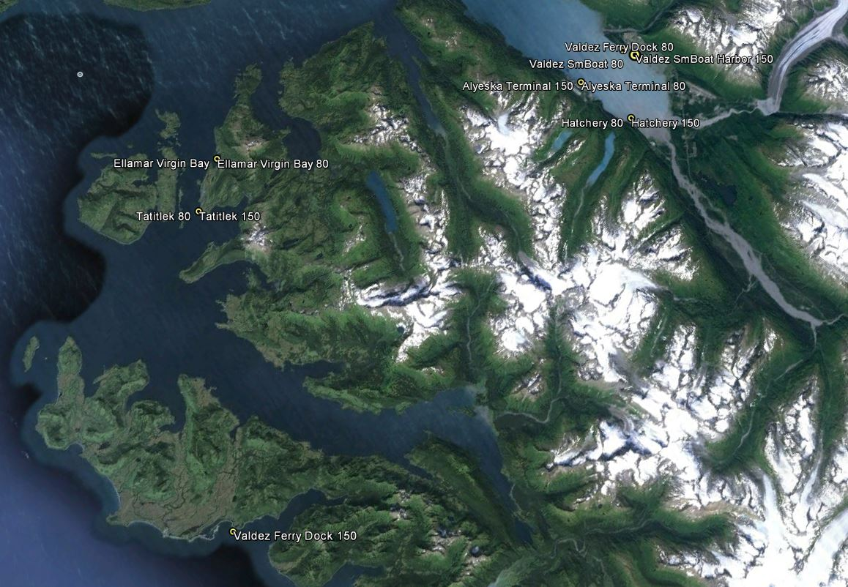

**Figure 2.** Top: Relation between OTUs produced by Geneious assembly (Appendix 1) and number of Ion Torrent PGM reads. There is a strong positive relationship, suggesting additional OTUs can be recovered by further sequencing. Bottom: Relation between eukaryotic marine taxa (less fungi) recovered and number of Ion Torrent PGM reads. There is little if any relationship, indicating that the sequencing depth accomplished recovered the majority of taxonomic diversity. The undiscovered diversity in the top panel likely represents prokaryotes and fungi.

Raw OTUs

**Figure 3**. Neighbor-joining tree of COI sequences showing the placement of the sequence ("unknown") recovered from Prince William Sound plankton and Genbank records (Genbank accession numbers removed for readability). The sequence has strong similarity to *Ilyanassa obsoleta*, but lies basal to a clade containing many I obsoleta. The occurrence in Prince William Sound may be a closely related species of nassariid snail, or plausibly a member of an unknown clade of *I. obsoleta*.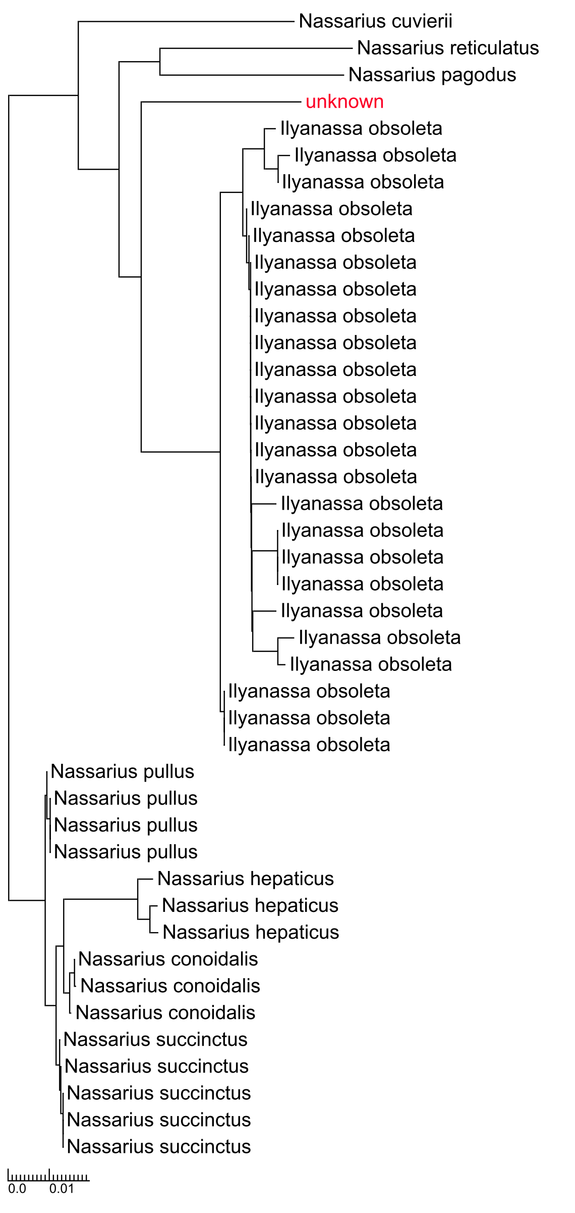

**Figure 4**. Neighbor-joining tree of COI sequences. An unknown sequence from Prince William Sound is deeply embedded in a clade of Genbank records (accession numbers removed for readability) of *Muscalista senhousia*, and identification as such is supported.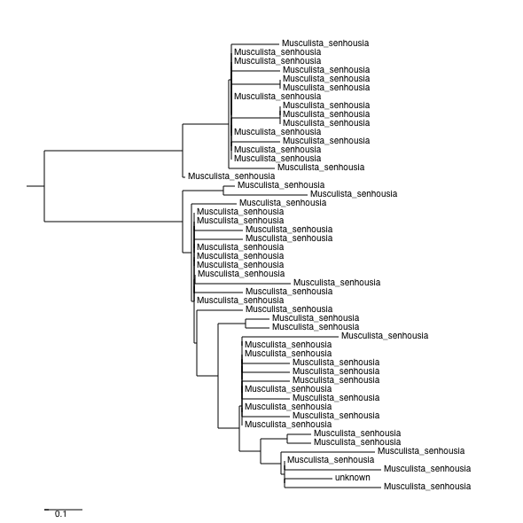

**Figure 5**. Neighbor-joining tree of COI sequences from Genbank records (accession names removed for clarity) of *Mya arenaria* and an unknown sequence from Prince William Sound. These sequences form clades with little variation within, and are distant from other bivalves represented in Genbank. An identification of the unknown sequence as *Mya arenaria* is supported.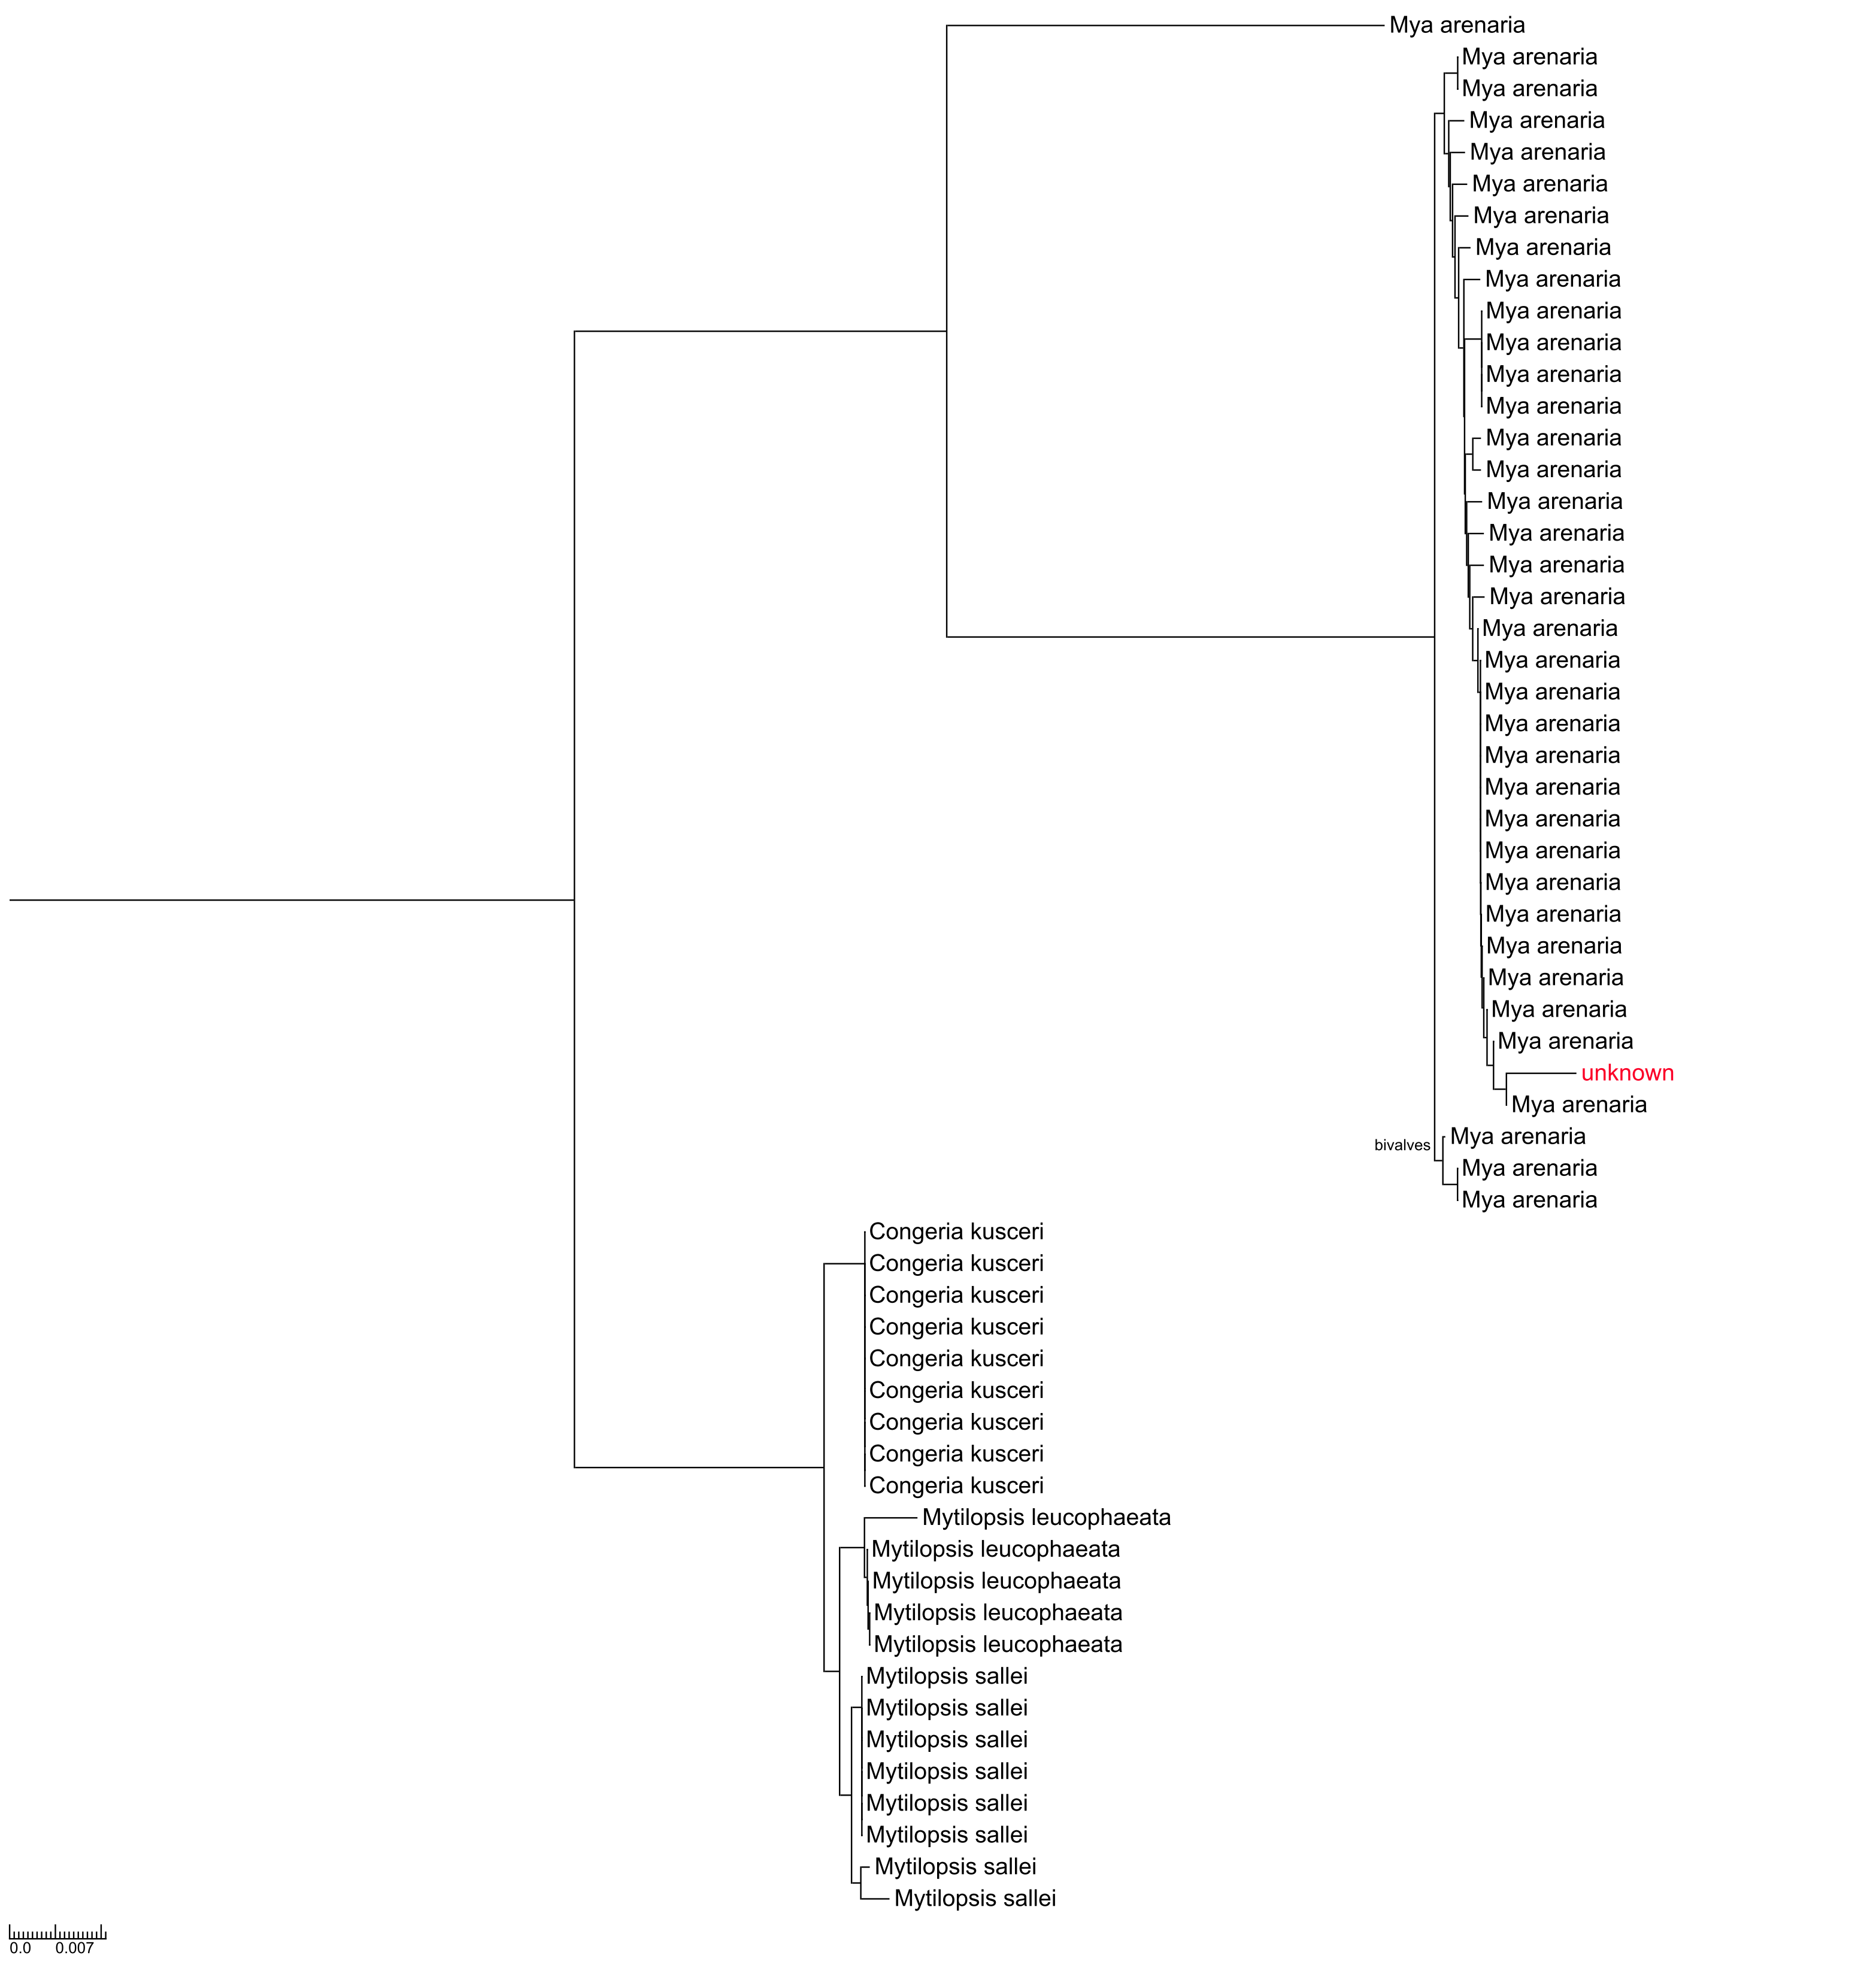

**Figure 6**. Neighbor-joining tree of COI sequences from Genbank records (accession names removed for clarity) of *Bugula* and other bryozoan sequences, and an unknown sequence from Prince William Sound. The unknown sequence is highly similar to *Bugula stolonifera* and *Bugula pacifica*, and a species assignment cannot be made if the Genbank records are correctly identified. Further analysis is presented in Figure 9.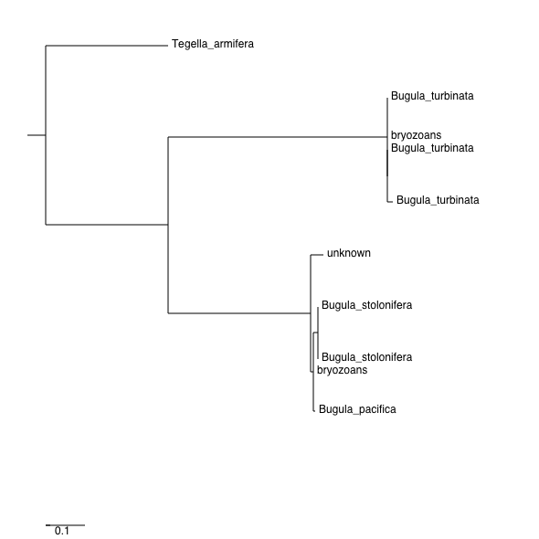

**Figure 7**. Neighbor-joining tree of Bugula COI sequences from vouchers collected in San Francisco Bay (specimen ID numbers removed for readability) of *Bugula* and other bryozoan sequences, and an unknown sequence from Prince William Sound. The unknown sequence is highly similar to *Bugula stolonifera* and distinct from *Bugula pacifica* and *B. neritina*. Identification of the unknown as *B. stolonifera* is supported if the vouchers were correctly identified.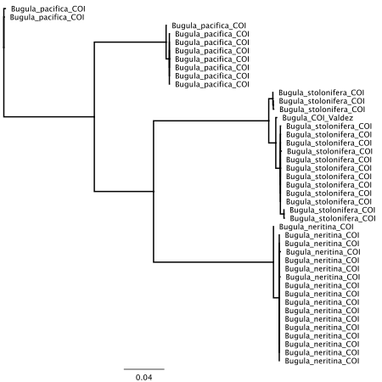

**Figure 8**. Neighbor-joining tree of COI sequences from Genbank of *Palaemon* *macrodactylus* and related species, and an unknown sequence from Prince William Sound, Alaska. The unknown sequence is nearly identical to Genbank records for *Palaemon* and distinct from other caridean shrimp. An identification as *P. macrodactylus* is supported.

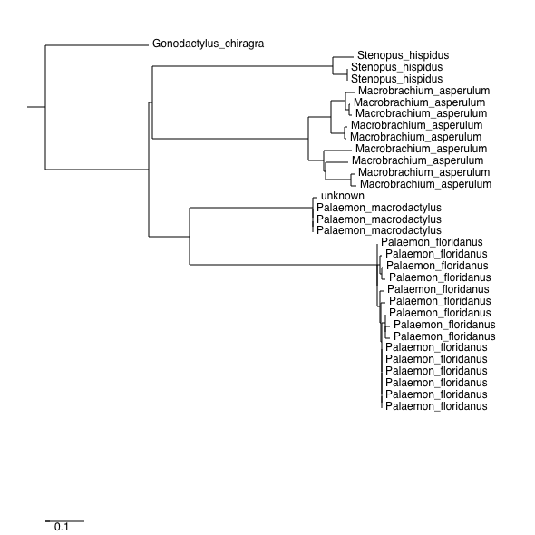

**Figure 9.** Neighbor-joining tree showing the placement of the sequence ("unknown") recovered from Prince William Sound plankton and Genbank records (Genbank accession numbers removed for readability). This sequence is identified as *Acartia tonsa.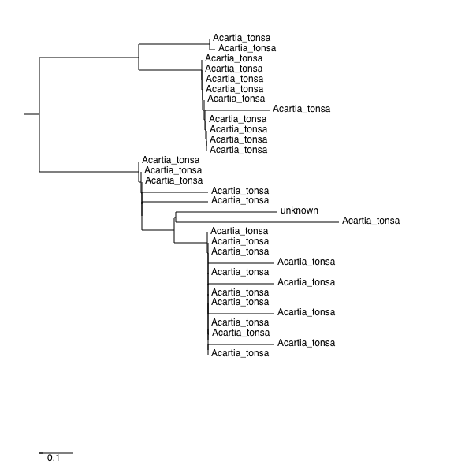*

**Figure 10**. Neighbor-joining tree showing the placement of the sequence ("unknown") recovered from Prince William Sound plankton and Genbank records (Genbank accession numbers removed for readability). This sequence is contained in a clade of *Acartia hudsonica*, and can be identified as such if the Genbank records are correctly identified. Note additional records identified as *A. hudsonica* within a clade of *A. clausii*.

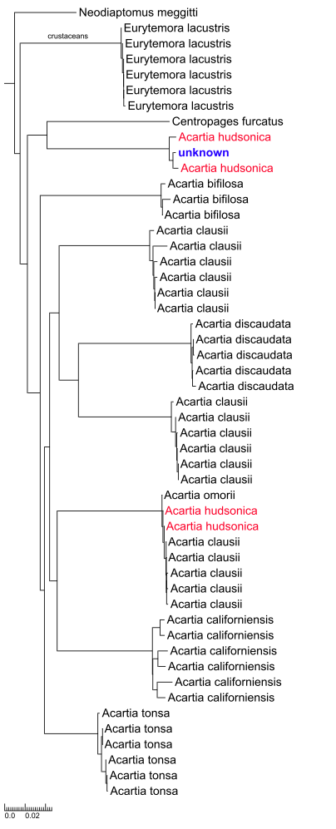

**Figure 11.** Neighbor joining tree of COI sequences from Genbank of *Cordylophora* and related hydrozoan species, and an unknown sequence from Prince William Sound. The unknown sequence is a member of one of two clades containing *Cordylophora*, but these are not further identified.

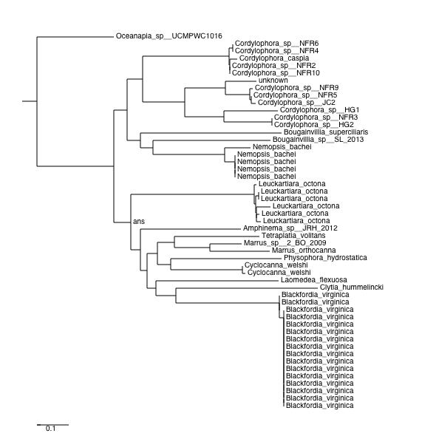

.

**Appendix 1: Custom Geneious Assembly Settings.**

Maximum gaps per read: 5

Maximum gap size: 3

Minimum overlap of reads: 200

Minimum overlap identity: 95%

Word length: 14

Index word length: 12

Ignore words repeated more than: 200 times

Reanalyze threshold: 8

Maximum mismatches per read: 5%

Maximum ambiguity: 64